1.and is located on the quote objects.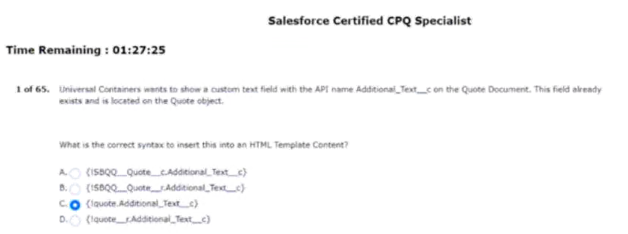
2.options by scrolling in a single page.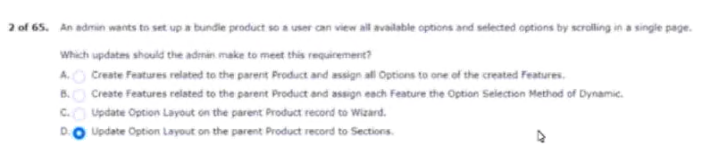
3.bundle and has a list price of $100.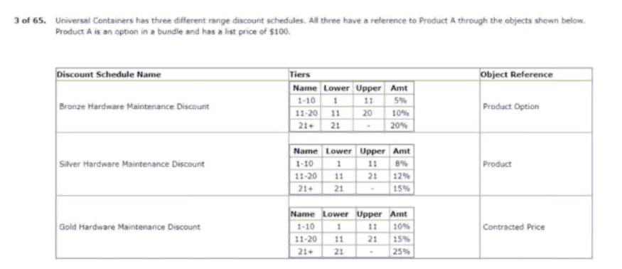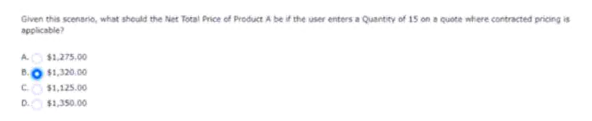
4.products in the storage product family.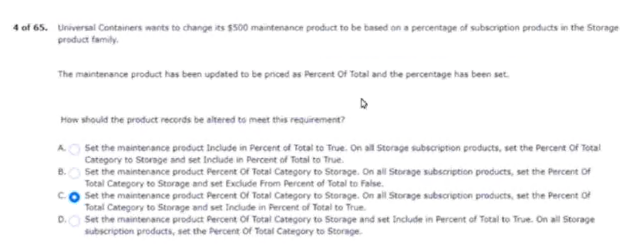
5.output documents in microsoft word format?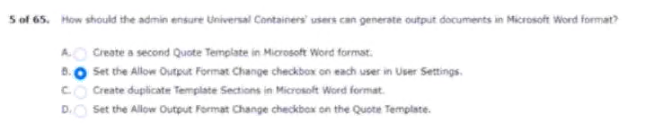
6.date upon contract activation.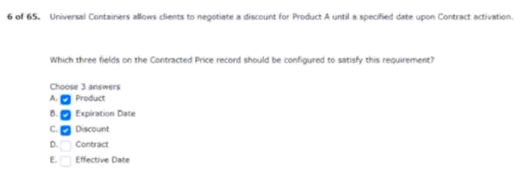
7.product A with these discount tiers: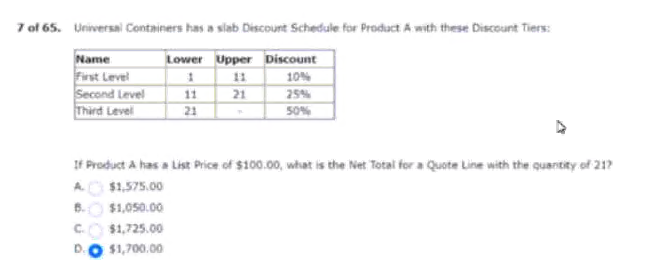
8.selects a specific configuration attribute.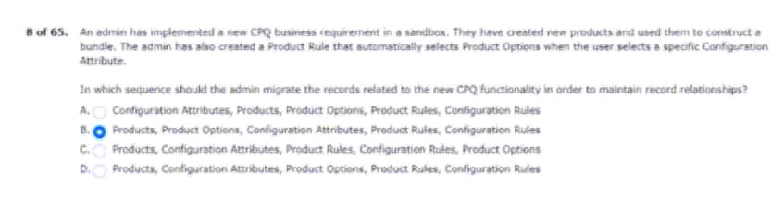
9.than the field from the product option.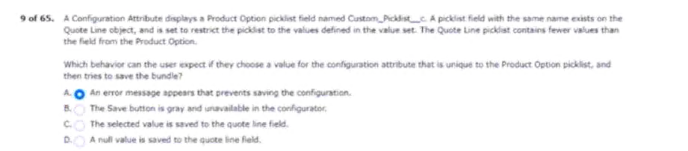
10.until the customers cancel their subscription.

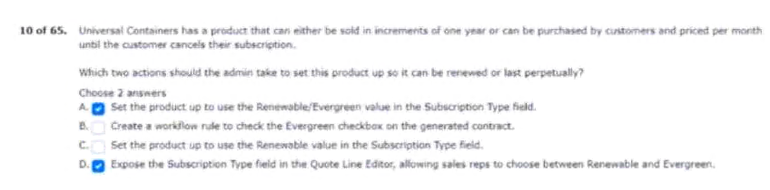
11.up permissions for internal sales users.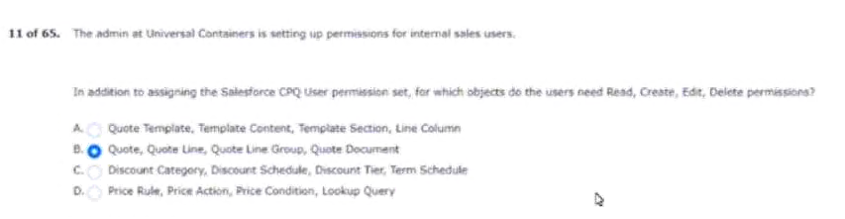
12.list products from product selection.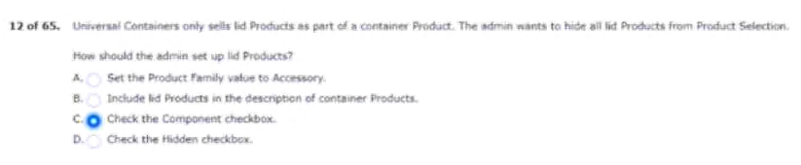
13.that is priced on a yearly basis.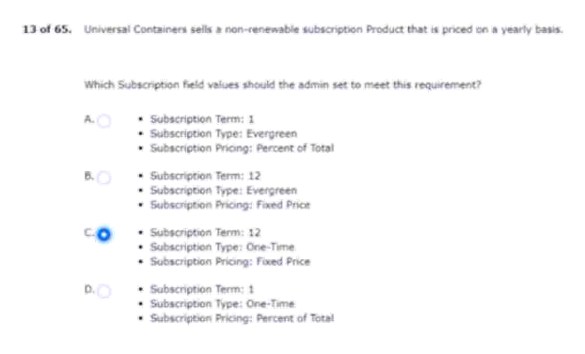
14.see when configuring the bundle.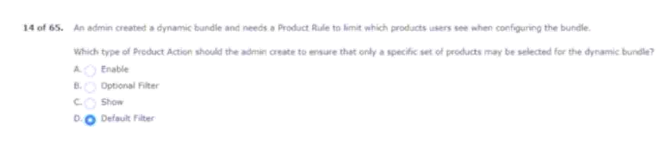
15.options for products A, B, C, and D.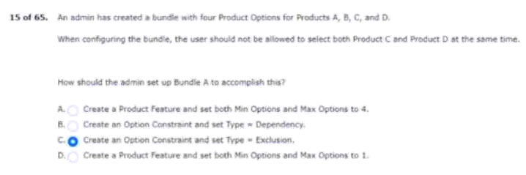
16.quantity via bundle configuration.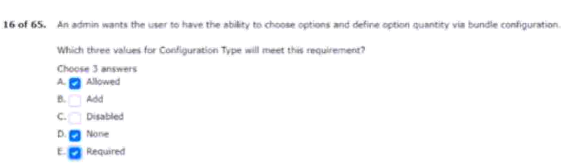
17.fire within this specific bundle.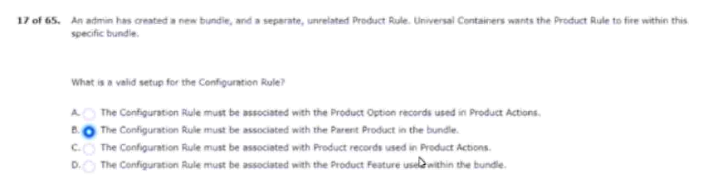
18.users specify the service level.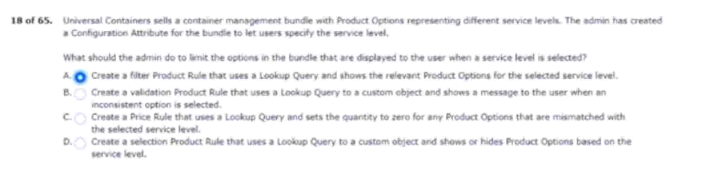
19.2 or term condition 3 is required.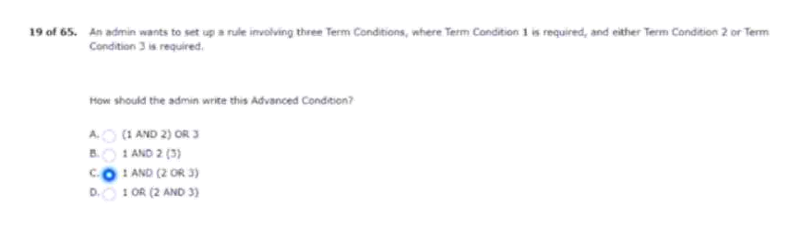
20.even if the opportunity is flagged as eco-friendly.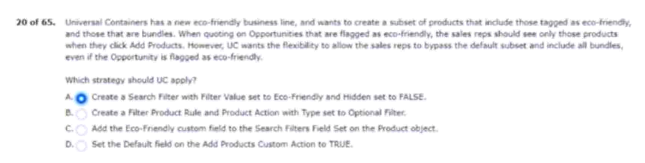
21.option to segment when needed.
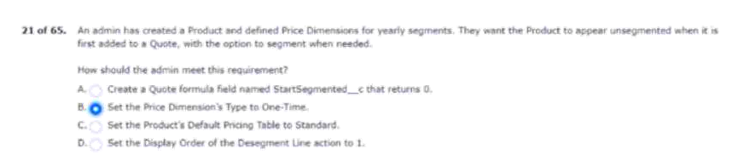
22.chains display on screen from left-to-right.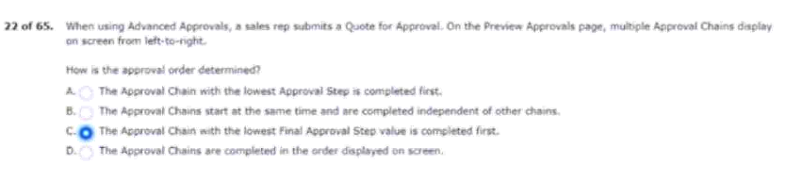
23.on the total subscription term as follows.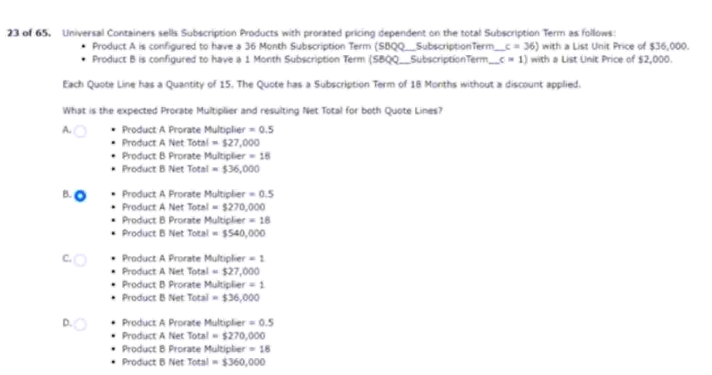
24.assert product in addition to another quote line.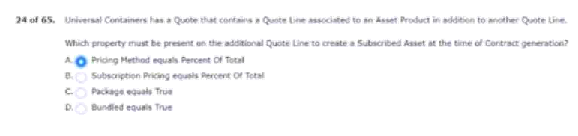
25.of an amount deducted from the last price.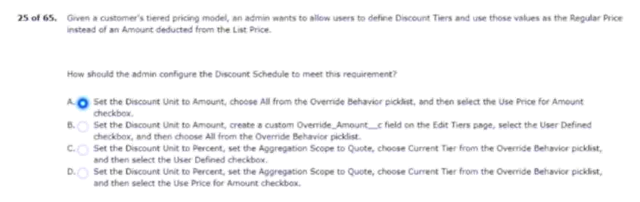
26.greater than 10, its price falls to $50.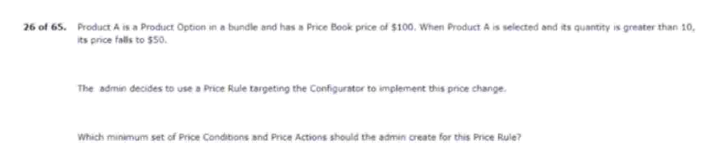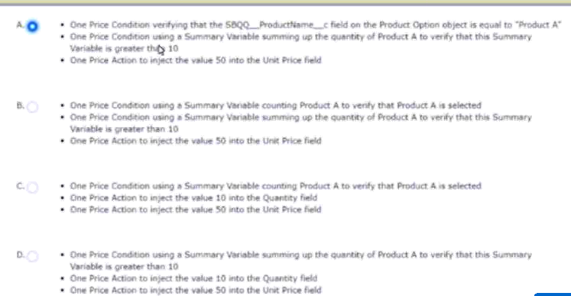
27.combination of asserts and subscriptions.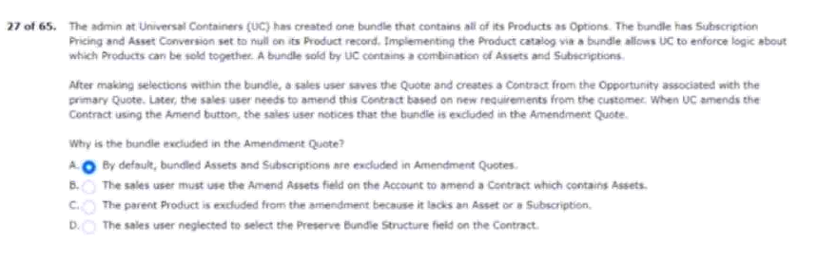
28.and has multi-currency enabled.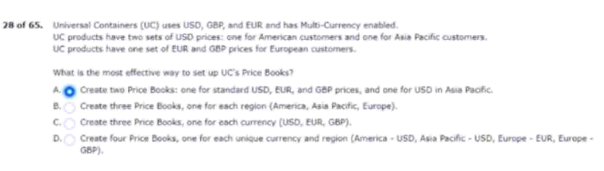
29.group based on the product family.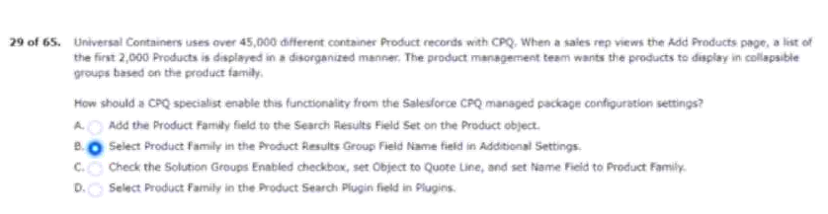
30.soon as the current contract is created.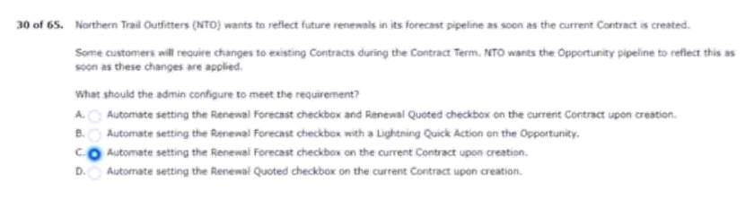
31.and zero error messages are displayed.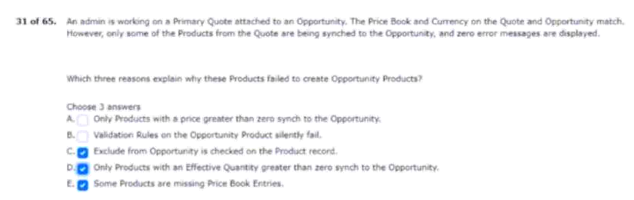
32.generating records for which object?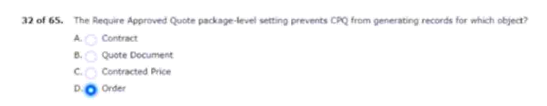
33.should apply only for the specific product.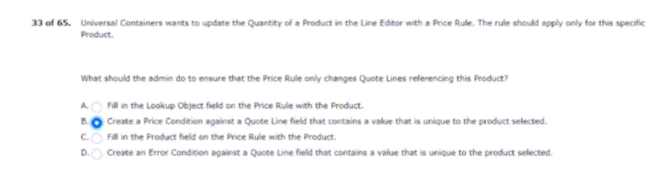
34.match the volume of every product option.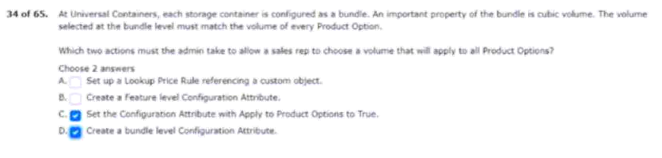
35.these pdf files are already stored in documents.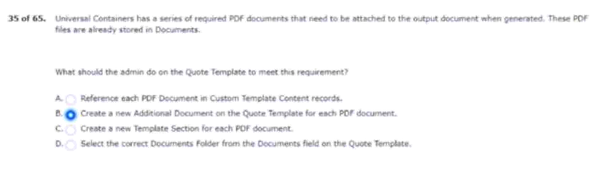
36.container products added to the quote.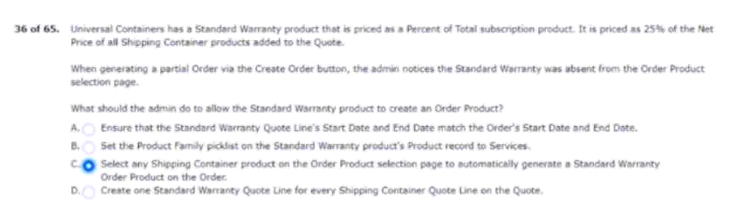
37.2019 and an end date of august 21, 2020.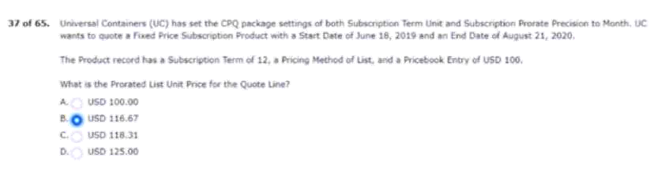
38.click calculate twice for the discount to apply.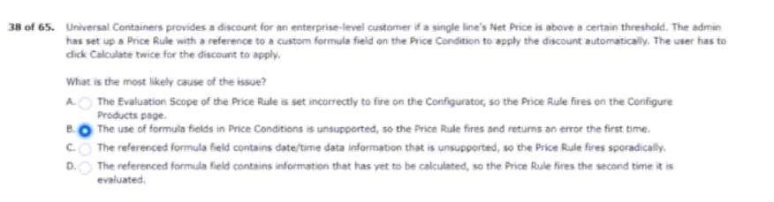
39.for existing active subscriptions and asserts.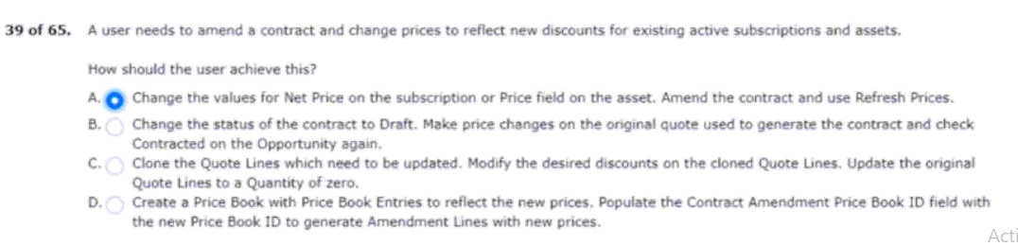
40.separate order per quote line group.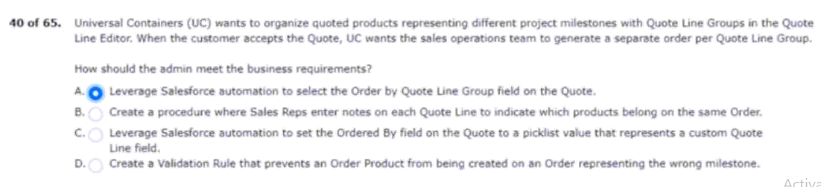
41.custom field still failed to populate.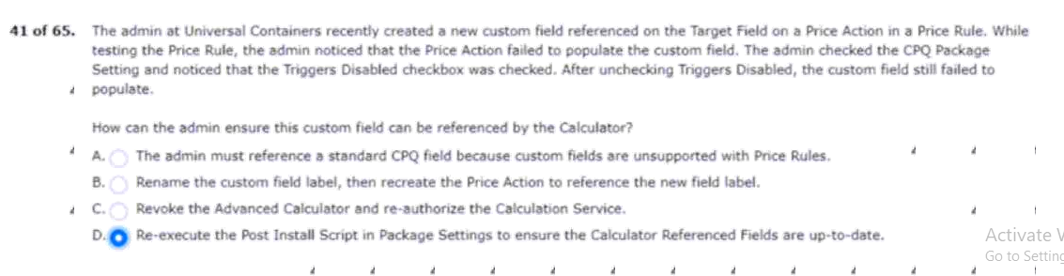
42.to change the configuration if desired.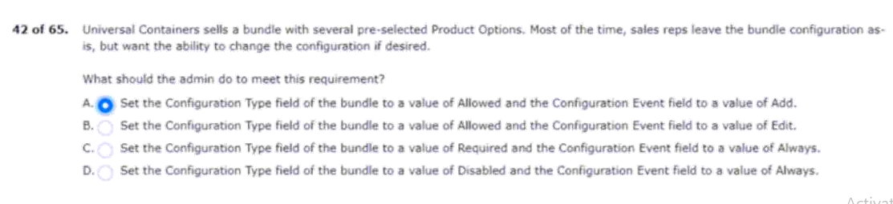
43.product family Y by 10% upon renewal.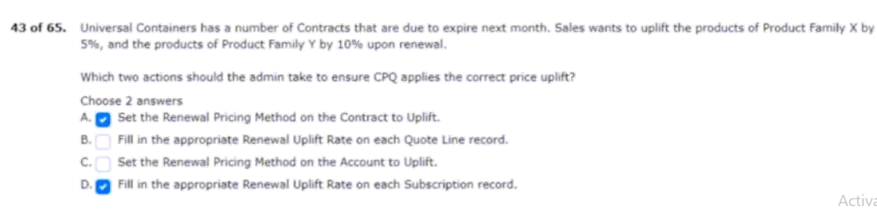
44.green and an operator of “starts with.”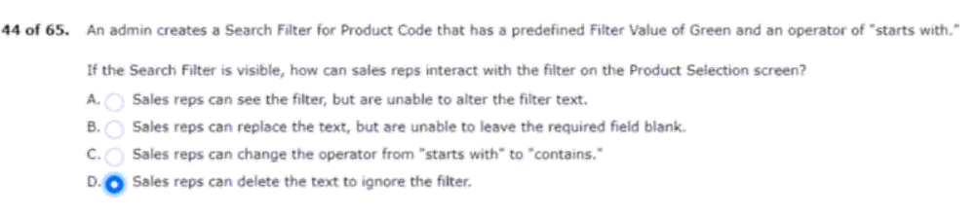
45.group in a single approval step?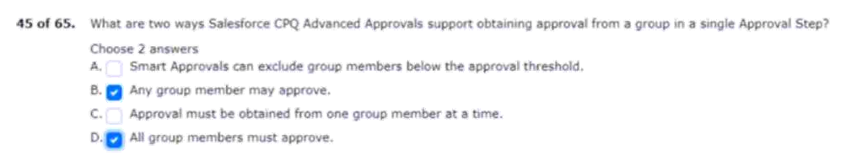
46.when the sales rep clicks calculate.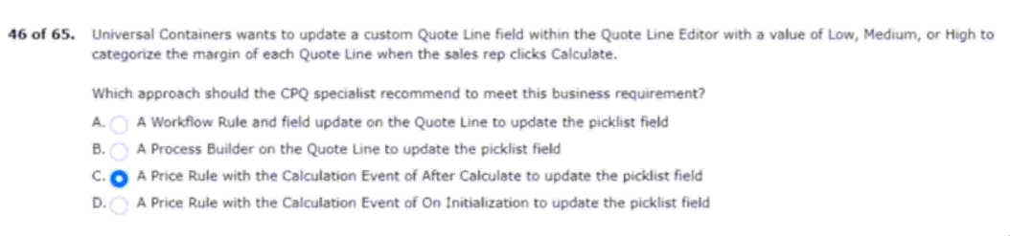
47.evaluation events and evaluation orders.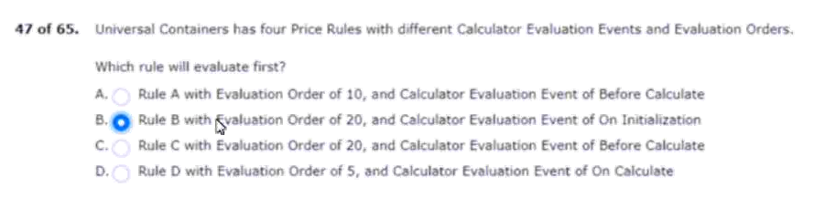
48.quote line fields in the quote line editor.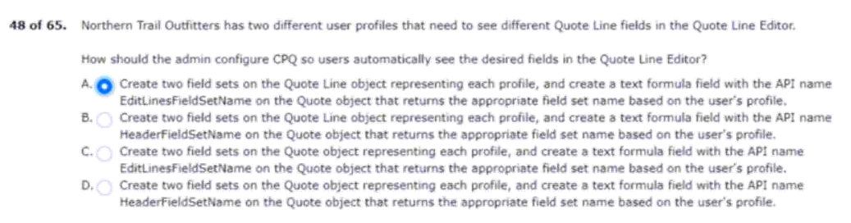
49.to the quote line editor, uc wants: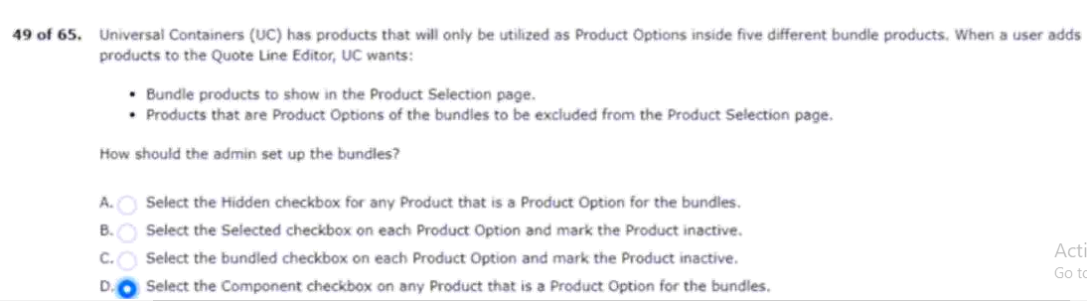
50.split orders by delivery location automatically.
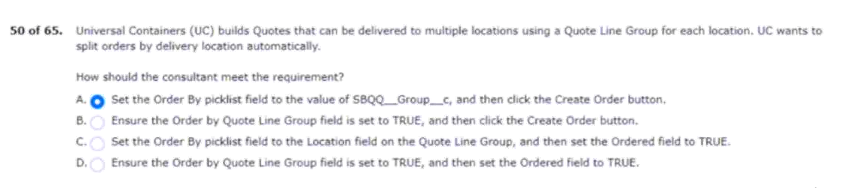
51.the price book from the opportunity.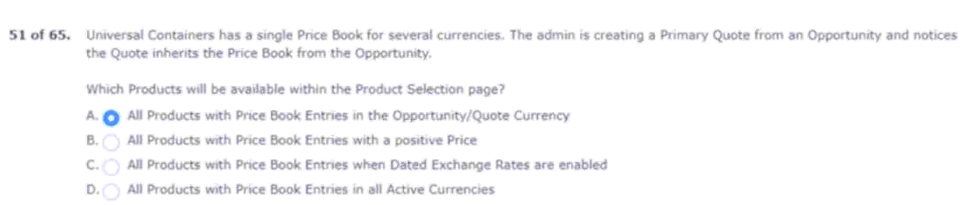
52.selection screen when users search for it.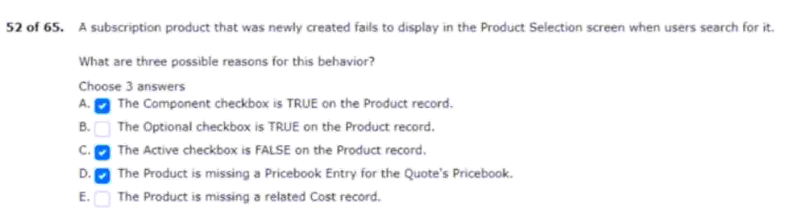
53.for all three products on a yearly basis.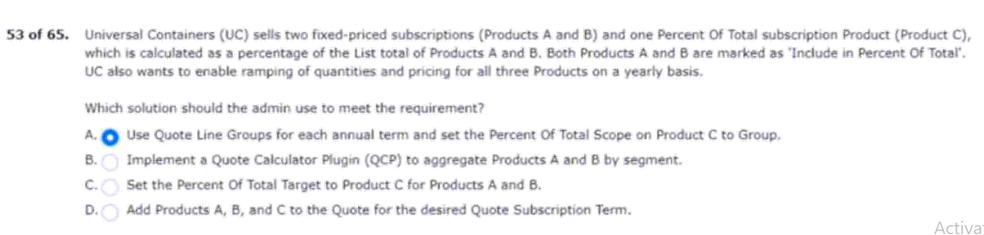
54.which characteristics of the quote line editor?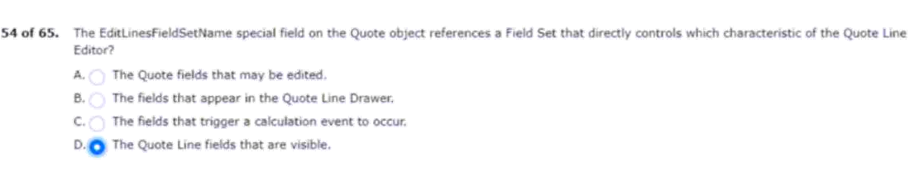
55.single product fails to result in a contract.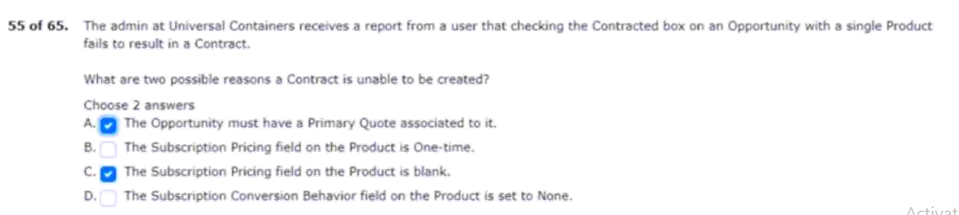
56.the quantity on an Order product?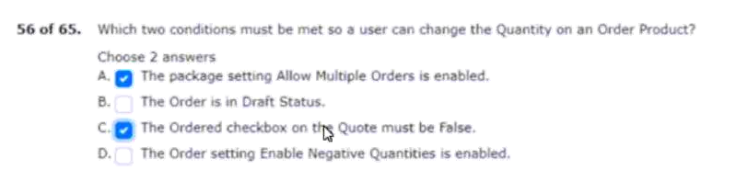
57.but can be removed by the user.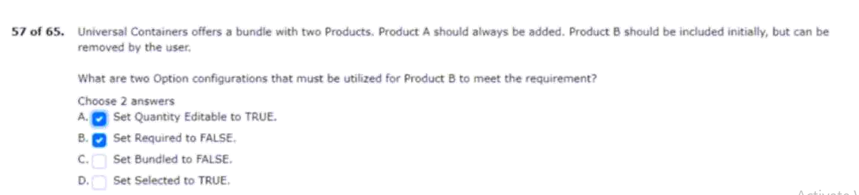
58.on the bundle product and its options. 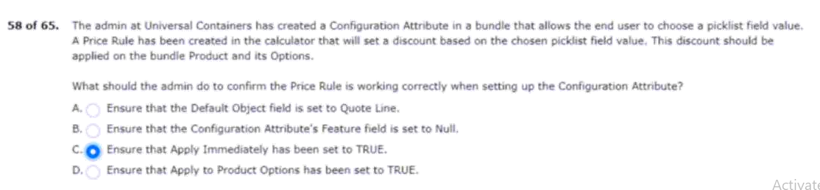
59.the user creates a renewal quote.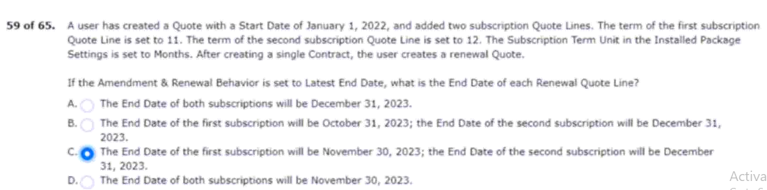
60.differs from the quote’s end date.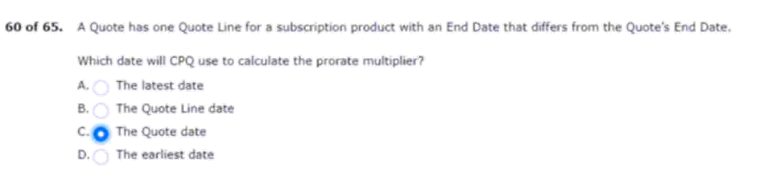
61.information on each contract record.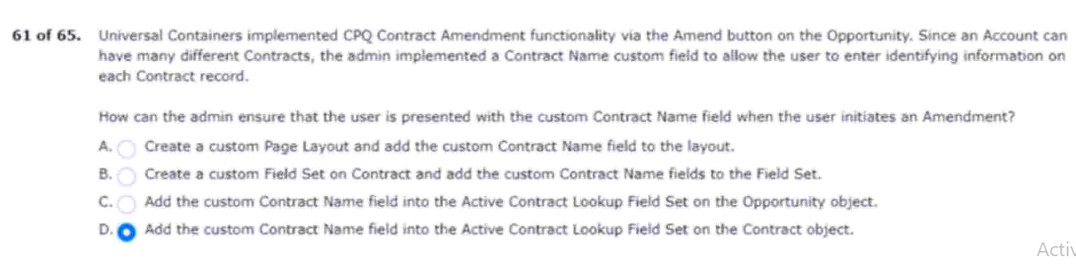
62.to respond to the approval request.
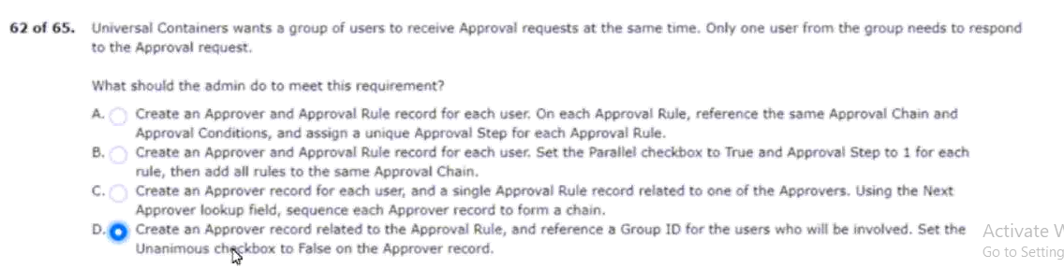
63.are valid for each container size.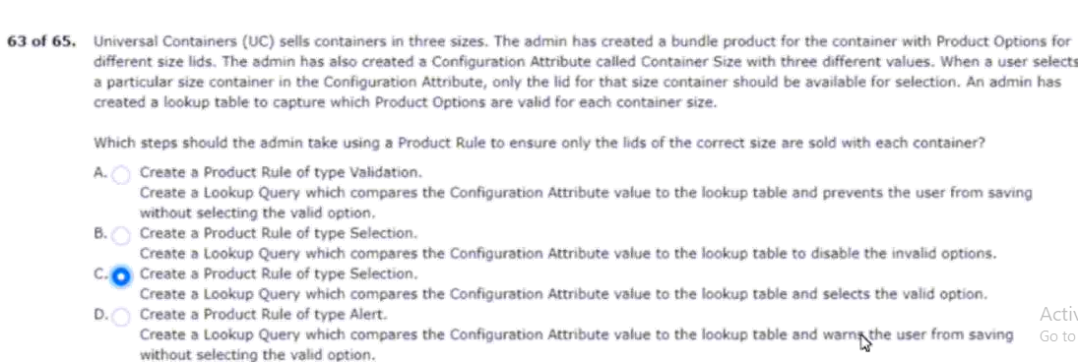
64.product A is a subscription product.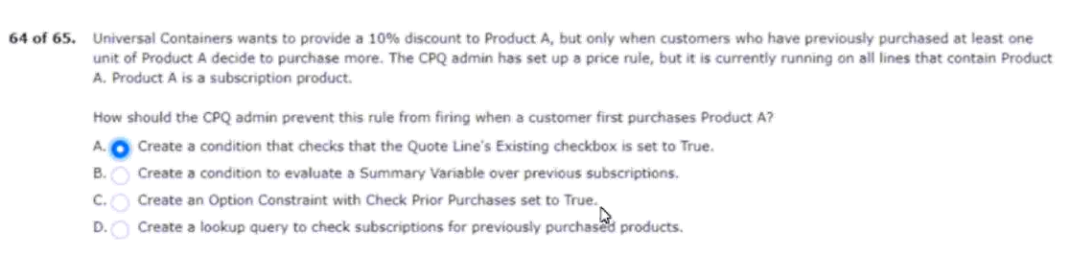
65.of the containers in the output document.